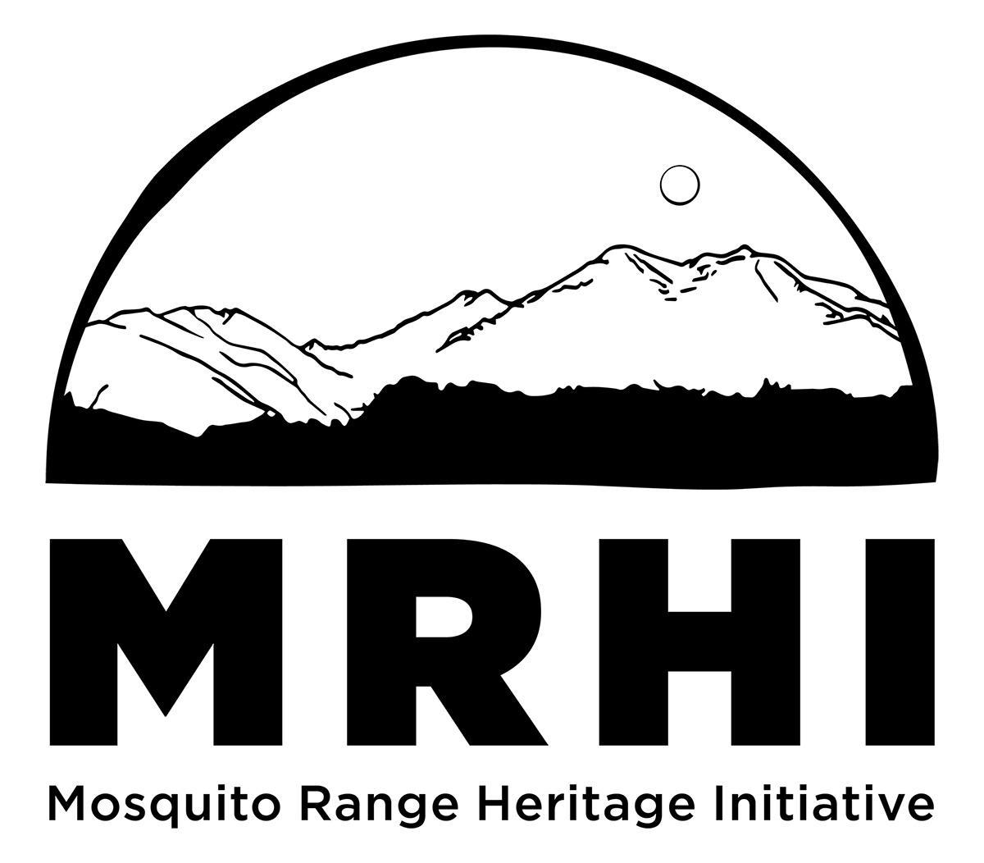
Mosquito Range Heritage Initiative
2023 Poker Ride Entry Form
Saturday, September 23, Fairplay, CO
9:00 REGISTRATION 10:00 AM GROUP START
Biker Waffles to start morning * Social hour to follow
USFS Tie Hack Trail - Thompson Park

Name:_______________________________________________ Phone:____________________

Address:____________________________________________ Email:__________________________

Additional/Family Members: Name 1)______________________ Name 2)___________________________

Name 3)______________________ Name 4)____________________________

ENTRY FEE: $25 (includes waffles, gift, chance at prizes + boosting conservation efforts)

Email the entry form to INFO@MRHI.ORG, or mail to: MRHI, PO Box 375, Alma, CO 80420
or bring the entry form with you on September 23, 2022.

Waiver: I, knowingly, and at my own risk, and in consideration for my acceptance as a participant, hereby forever waive and release any and all claims for any injury that I may incur, or any family member listed below may incur, as a direct or indirect result of my participation in this event. By my signature, I/we agree to hold harmless any of the sponsors or any of their employees, or any race official or administrator, or the Mosquito Range Heritage Initiative or any of its members.

Waiver must be signed:______________________________________________

NOTES: Please be self-sufficient. Please bring snacks, water, extra clothes, first aid kit, repair kits.

Check back in! When you finish the course, or drop out and go home, YOU MUST CHECK OUT at the registration table. Otherwise if we cannot reach you after the ride, you will be considered lost and Search and Rescue will be called.

Poker Rules: You will pick a card from a deck at the 4 rest stops along the route, and then the 5th card back at the registration table after you complete the route. Write down your selection on a form that will be provided. The ride official at the rest stops/registration table will also record your selection for verification purposes. You cannot duplicate a selection, i.e. if you have already picked the Ace of Spades on a previous draw, you must redraw another card. Best hand raking: Straight Flush, 4-of-a-kind, Full House, Flush, Straight, 3-of-a-kind, 2 pair, 1 pair. High card breaks ties. Ace can be high or low. Worst hand ranking: Lowest cards in different suits w/ no pairs, i.e. 2-3-4-5-7 is the ‘best’. Aces are not considered low in a ‘worst’ hand. If there are ties for best/worst hand, the players will cut cards – Ace is high. Sorry, only one winner in the best and worst hand categories.

THANK YOU VERY MUCH for supporting our non-profit, volunteer-based efforts!!!!!
“The Mosquito Range Heritage Initiative, through cooperative efforts,
seeks to conserve unique natural areas, preserve historic and cultural sites, and promote diverse recreation”
www.MRHI.org

